# **STM32Duino的引脚映射ADC，PWM等**

基于迷你强的STM32duino文章，感觉非常有价值，这小单片机做Arduino实在太强了，甩AVR的几条街，结合Maple Mini研究了一下，总结下面基础资料：

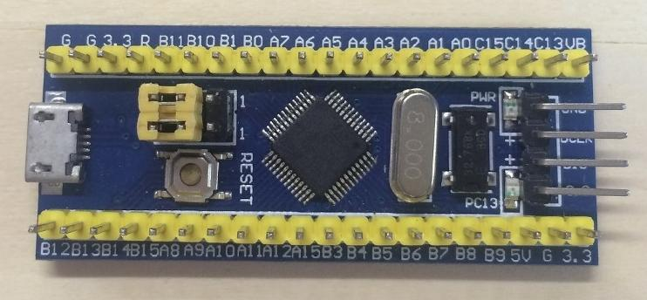

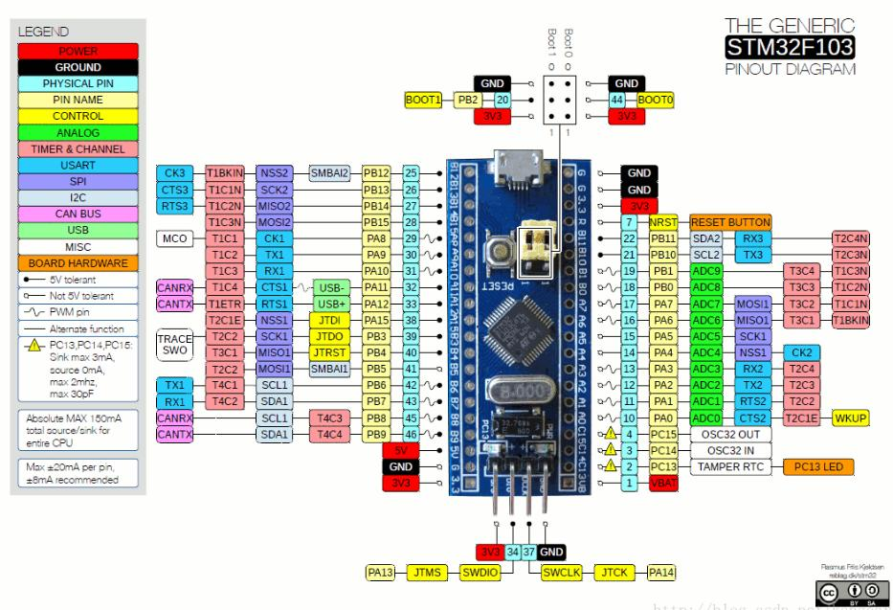

## **0、编程语法参考**

<http://docs.leaflabs.com/static.leaflabs.com/pub/leaflabs/maple-docs/latest/language.html>

## **1、引脚对应关系：**

32个GPIO，也可以用序号表达。

序号 物理引脚

0 PA0

1 PA1

2 PA2

3 PA3

4 PA4

5 PA5

6 PA6

7 PA7

8 PA8

9 PA9

10 PA10

11 PA11

12 PA12

13 PA13

14 PA14

15 PA15

16 PB0

17 PB1

18 PB2

19 PB3

20 PB4

21 PB5

22 PB6

23 PB7

24 PB8

25 PB9

26 PB10

27 PB11

28 PB12

29 PB13

30 PB14

31 PB15

32 PC13

33 PC14

34 PC15

## **2、允许PWM引脚：**

序号 物理引脚

0 PA0

1 PA1

2 PA2

3 PA3

6 PA6

7 PA7

8 PA8

9 PA9

10 PA10

16 PB0

22 PB6

23 PB7

PWM引脚简易测试程序，总共有12个PWM引脚，16bit即65536级PWM，很精密了：

void setup()

{

pinMode(PB0, PWM);

pinMode(PA7, PWM);

pinMode(PA6, PWM);

pinMode(PA3, PWM);

pinMode(PA2, PWM);

pinMode(PA1, PWM);

pinMode(PA0, PWM);

pinMode(PB7, PWM);

pinMode(PB6, PWM);

pinMode(PA10, PWM);

pinMode(PA9, PWM);

pinMode(PA8, PWM);

}

void loop()

{

for (int i = 0; i < 65536; i++)

{

delayMicroseconds(40);

pwmWrite(PB0, i);

pwmWrite(PA7, i);

pwmWrite(PA6, i);

pwmWrite(PA3, i);

pwmWrite(PA2, i);

pwmWrite(PA1, i);

pwmWrite(PA0, i);

pwmWrite(PB7, i);

pwmWrite(PB6, i);

pwmWrite(PA10, i);

pwmWrite(PA9, i);

pwmWrite(PA8, i);

}

}

PWM精度太高了，驱动LED没必要那么高，再来一个指数式适合驱动LED的，看起来亮度更线性。

void setup() {

pinMode(PB0, PWM);

pinMode(PA7, PWM);

pinMode(PA6, PWM);

pinMode(PA3, PWM);

pinMode(PA2, PWM);

pinMode(PA1, PWM);

pinMode(PA0, PWM);

pinMode(PB7, PWM);

pinMode(PB6, PWM);

pinMode(PA10, PWM);

pinMode(PA9, PWM);

pinMode(PA8, PWM);

}

void loop() {

*//指数式增加亮度，适合驱动LED，看起来亮度更线性*

for (int i = 0; i < 256; i++)

{

delay(20);

pwmWrite(PB0, i * i);

pwmWrite(PA7, i * i);

pwmWrite(PA6, i * i);

pwmWrite(PA3, i * i);

pwmWrite(PA2, i * i);

pwmWrite(PA1, i * i);

pwmWrite(PA0, i * i);

pwmWrite(PB7, i * i);

pwmWrite(PB6, i * i);

pwmWrite(PA10, i * i);

pwmWrite(PA9, i * i);

pwmWrite(PA8, i * i);

}

}

或者用序号表示：

int pins[12] = {0, 1, 2, 3, 6, 7, 8, 9, 10, 16, 22, 23};

void setup()

{

for (int i = 0; i < 12; i++)

{

pinMode(pins[i], PWM);

}

}

void loop()

{

for (int i = 0; i < 100; i++)

{

for (int j = 0; j < 12; j++)

{

pwmWrite(pins[j], i * i);

}

delay(20);

}

}

## **3、允许的**[ADC](https://so.csdn.net/so/search?q=ADC&spm=1001.2101.3001.7020)**引脚：**

ADC总共有10个通道，12bit即4096级。引脚如下

物理引脚，ADC通道PA0 CH0

PA1 CH1

PA2 CH2

PA3 CH3

PA4 CH4

PA5 CH5

PA6 CH6

PA7 CH7

PB0 -(不能用序号表达)

PB1 -(不能用序号表达)1

ADC测试程序：

void setup()

{

Serial.begin(115200);

pinMode(PB0, INPUT_ANALOG);

pinMode(PA7, INPUT_ANALOG);

pinMode(PA6, INPUT_ANALOG);

pinMode(PA5, INPUT_ANALOG);

pinMode(PA4, INPUT_ANALOG);

pinMode(PA3, INPUT_ANALOG);

pinMode(PA2, INPUT_ANALOG);

pinMode(PA1, INPUT_ANALOG);

pinMode(PA0, INPUT_ANALOG);

pinMode(PB1, INPUT_ANALOG);

}

void loop()

{

delay(50);

Serial.print("\tPB0="); Serial.print(analogRead(PB0));

Serial.print("\tPA7="); Serial.print(analogRead(PA7));

Serial.print("\tPA6="); Serial.print(analogRead(PA6));

Serial.print("\tPA5="); Serial.print(analogRead(PA5));

Serial.print("\tPA4="); Serial.print(analogRead(PA4));

Serial.print("\tPA3="); Serial.print(analogRead(PA3));

Serial.print("\tPA2="); Serial.print(analogRead(PA2));

Serial.print("\tPA1="); Serial.print(analogRead(PA1));

Serial.print("\tPA0="); Serial.print(analogRead(PA0));

Serial.print("\tPB1="); Serial.println(analogRead(PB1));

## **4、允许的串口**

总共3个硬件外接串口Serial1、Serial2、Serial3，一个USB虚拟串口Serial：

void setup()

{

Serial.begin(115200);

Serial1.begin(115200); *//TX=PA9,RX=PA10*

Serial2.begin(115200); *//TX=PA2,RX=PA3*

Serial3.begin(115200); *//TX=PB10,RX=PB11*

}

void loop()

{

delay(100);

Serial.println("Test Serial");

Serial1.println("Test Serial1");

Serial2.println("Test Serial2");

Serial3.println("Test Serial3");

}